**Business Question and Visualization Report**

|  |  |
| --- | --- |
| Date | 17 June 2025 |
| Project Name | Global Energy Trends: A Comprehensive  Analysis of Key Regions and Generation  Modes using Power BI |
| Maximum Marks | 5 Marks |

Visualization development refers to the process of creating graphical representations of data to facilitate understanding, analysis, and decision-making. The goal is to transform complex datasets into visual formats that are easy to interpret, enabling users to gain insights and make informed decisions. Visualization development involves selecting appropriate visual elements, designing layouts, and using interactive features to enhance the user experience. This process is commonly associated with data visualization tools and platforms, and it plays a crucial role in business intelligence, analytics, and reporting

**Business Questions and Visualisation**

The process involves defining specific business questions to guide the creation of meaningful and actionable visualizations in Power BI. Well-framed questions help in identifying key metrics, selecting relevant data, and building visualisation that provide insights.

**Complete Business Questions and Visualizations - Global Energy Trends**

1**. What is the total global contribution of each renewable energy source?**

* *Visualization*: Bar Chart (TWh by Source)
* *Screenshot of visualisation*

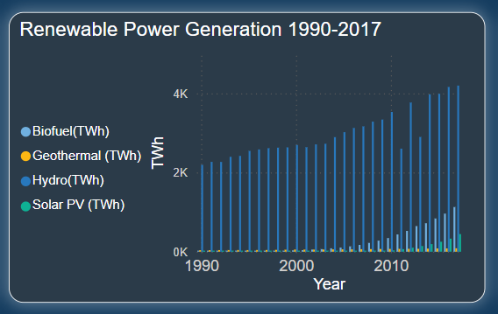

2. **How does global energy consumption differ across continents over time?**

* *Visualization*: Line Chart (Continent-wise over time)
* *Screenshot of visualisation*

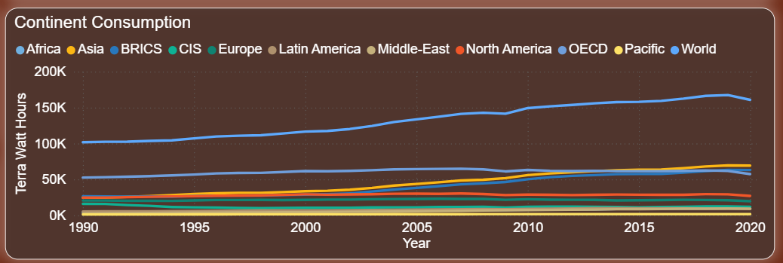

3. **Which countries contribute the most to energy consumption?**

* *Visualization*: Line Chart (Country-wise over time)
* 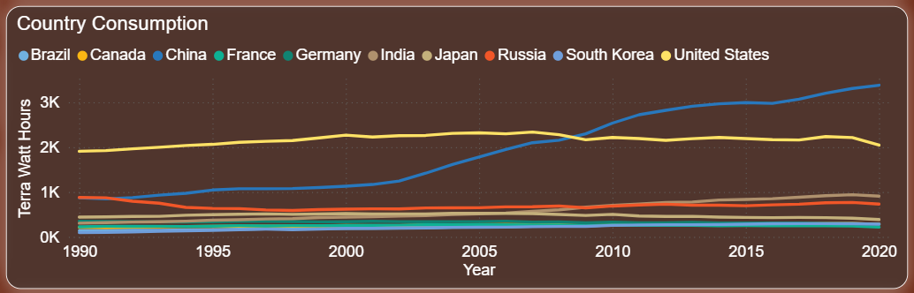*Screenshot of visualisation*

4. **What is the contribution of each non-renewable energy source globally?**

* *Visualization*: Pie Chart
* *Screenshot of visualisation*

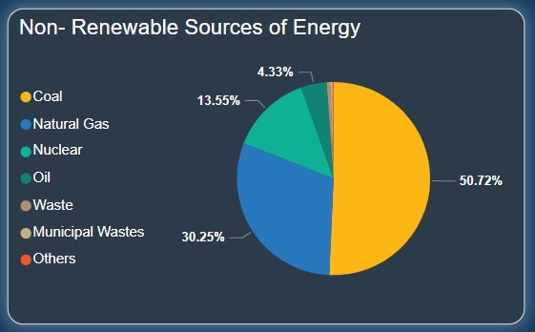

5. **What is the average energy consumption per continent and per country?**

* *Visualization*: KPI Cards
* *Screenshot of visualisation*

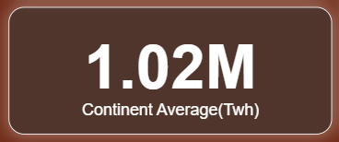



6. **What is the standard deviation, median, and sum of global energy contributions?**

* *Visualization*: KPI Cards
* *Screenshot of visualisation*

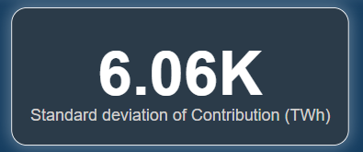

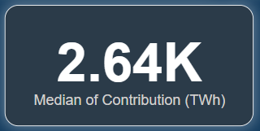

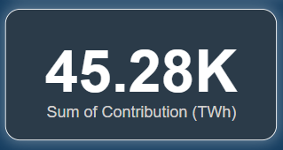7. **What is the variance of global energy contributions?**

* *Visualization*: KPI Card showing variance
* *Screenshot of visualisation*

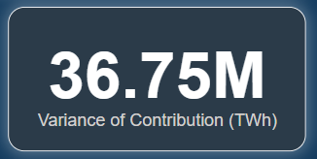

8. **What is the proportion of renewable sources in total energy generation?**

* *Visualization*: Donut Chart (Solar, Hydro, Wind, Geothermal, Bio)
* *Screenshot of visualisation*

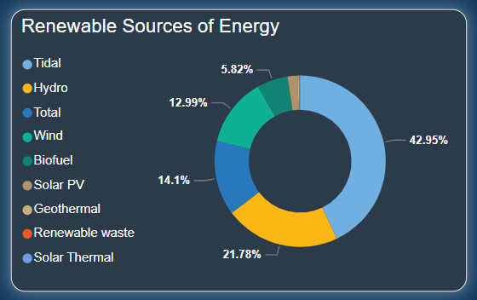

9. **What is the total contribution of Biofuel energy globally?**

* *Visualization*: KPI Card (Sum of Biofuel in TWh)
* *Screenshot of visualisation*

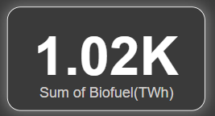

10. **What are the individual contributions of Geothermal, Hydro, and Solar PV?**

* *Visualization:* KPI Cards (One card for each source)
* *Screenshot of visualisation*

